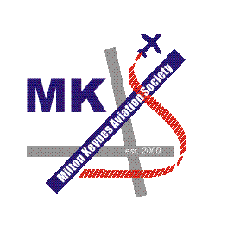

MILTON KEYNES

AVIATION SOCIETY

VISITS PROGRAMME

2003

DATE | VISIT
Thursday 27th March 2003. | RAF Shawbury.  Another excellent tour of the storage facilities at this base, plus a look at the Horsa restoration and the Defence Helicopter Flying School (DHFS).
Sunday 12th April 2003. | Bruntingthorpe.  As guests of the Lightning Preservation Group, we were treated to another excellent visit to this airfield, which now boasts a Boeing 747, being converted to a conference facility. Also visits to other areas of the airfield not seen on our previous visit to Bruntingthorpe in October 2000.
Saturday 14th June 2003. | RAF Scampton.  An excellent visit to the home of the Red Arrows and their Hawks. Plus a look around this historic base, as well as the stored and museum aircraft.
Saturday 19th July 2003. | Yorkshire Air Museum.  A visit north to this excellent museum, which boasts amongst many others, a composite Halifax II ‘LV907’.
Saturday 2nd August 2003. | Air Atlantique & Coventry Air Museum.  A visit to Air Atlantique in Coventry and a chance to fly in one of either DC-3, Rapide, Twin Pioneer or Prentice - all for £40 a head. Followed by a visit to the superb Coventry Air Museum located beside the airfield.
Thursday 7th August 2003. | HMS Sultan.  A very informal visit to see the inmates at the Royal Navy equivalent to RAF Cosford, where approximately 60 helicopters (Merlin, Gazelle, Wessex and Sea King) were seen.
Tuesday 21st October 2003. | RAF Brize Norton.  A superb all day visit, hosted by 10 Squadron, who operate the VC-10 C.1K. With an excellent lunch at the Sergeants mess, visits were also made to Cargo, Movements, Maintenance, Load Training and Air Traffic Control.
Tuesday 20th November 2003. | RAF Northolt.  An excellent visit to this West London base, with visits to the hangars, ATC tower, fire station and movements area as well as a visit to the RRDU chart printing area

