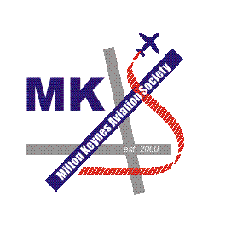
rk

MILTON KEYNES

AVIATION SOCIETY

VISITS PROGRAMME

2000

DATE | VISIT
Thursday 21st June 2000 | Turweston Flying Evening.  A delightful evening at a delightful airfield with a chance to do some flying, as well as enjoy a lovely summers evening.
Thursday 31st August 2000. | LATCC in West Drayton.  A superb visit to the London Area Terminal Control Centre at West Drayton, to see Air Traffic Control over the southern United Kingdom in action.
Saturday 23rd September 2000. | Manchester and Woodford.  A visit to this busy northern airport and a quick visit to Woodford to see what is parked out at this, the home of the BAe 146.
Saturday 21st October 2000. | Bruntingthorpe.  Visit to see the aircraft preserved at this private Leicestershire airfield, ranging from Lightning's, Buccaneer, Victor, Tristar and Guppy to Let 410's and lots more goodies.  A chance was also taken to have a look at the "Lady in Waiting" - Vulcan B.2 XH558, while she gets ready to fly again.

