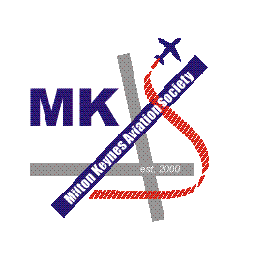
rk

MILTON KEYNES

AVIATION SOCIETY

VISITS PROGRAMME

2004

DATE | VISIT
Tuesday 10t^{h} February 2004. | RAF Mildenhall.  A superb visit to this USAF base, with an excellent lunch at the Galaxy Club to boot. Visits were made to the Emergency and Safety section as well as a presentation on "Passing Gas" by the 100th ARW, with a static KC-135R for us to clamber over. A terrific day out was had by all.
Thursday 18th March 2004. | RAF Wittering.  An excellent visit to the Harrier training base, where we had a very interesting visit to the power plant overhaul and repair shop, Air Traffic Control to see approach control and watch manoeuvres from the balcony and then we were allowed to crawl around a Harrier in the 20 Squadron hanger. Another great MKAS day out.
Sunday 25th April 2004. | De Havilland Museum Aircraft Heritage Centre & Mosquito Aircraft Museum.  A visit to the excellent collection of all things De Havilland, in Salisbury Hall, London Colney. With aircraft ranging from a Mosquito to a DH.106 Comet and with everything else in between, this is a superb place to visit.
Tuesday 10th August 2004. | HMS Sultan & Southampton Hall of Aviation.  A return visit to see all the training airframes at the Royal Navy equivalent of RAF Cosford, with Sea Kings, Gazelles and Wessei aplenty and more.  Followed by a visit to the excellent museum in Southampton.
Tuesday 7th September 2004. | RAF Odiham & RAF Benson.  The first double base visit for MKAS. A return visit to see the Chinooks at RAF Odiham followed by our first visit to the home of the Puma and Merlin fleets at RAF Benson.  A great visit was had by all to both bases.
Thursday 23rd September 2004. | RAF Shawbury.  Yet another return visit to this RAF storage base, where we saw not only the stored aircraft, but also the Griffins and Squirrels of the Defence Helicopter Flying School, as well as the Horsa project which has made excellent progress since our last visit and is set for completion by March 2005. Another superb day out.

